Chapters 1, 3, 4, 5, 6, 7, 8, 9

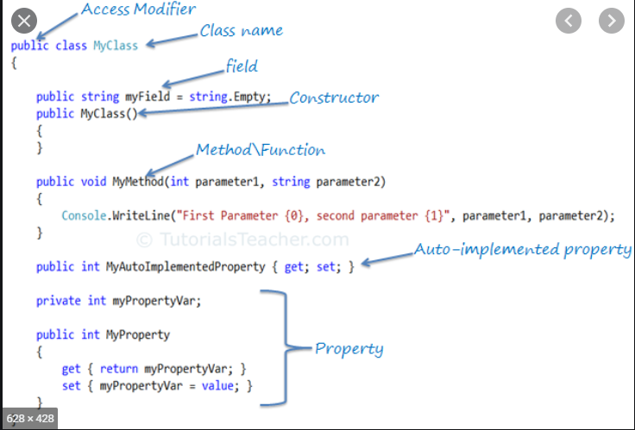

Chapter 1

**Record:** Employee

**Fields:** ◘ Employee identification number (a whole number)

◘Name (a string of characters)

◘ Address (a string of characters)

◘ Hourly pay rate (a number with a decimal point)

◘ Year-to-date earnings (a number with a decimal point)

◘ Amount of taxes withheld (a number with a decimal point)

**File:** A file is a group of related records.

**Database:** A database is a collection of data that’s organized for easy access and manipulation

**C#**: is an object-oriented programming language.

**Generic Programming:** It’s common to write a program that processes a collection of things.

**Functional Programming**: With functional programming, you specify what you want to accomplish in a task, but not how to accomplish it.

In most programming today, each task in a program must finish executing before the next task can begin **(Synchronous programming)**

C# also allows asynchronous programming in which multiple tasks can be performed at the same time.**(Asynchronous programming).**

**Common Language Runtime:** The Common Language Runtime (CLR) executes .NET programs and provides functionality to make them easier to develop and debug

**The CLR is a virtual machine:** (VM)—software that manages the execution of programs and hides from them the underlying operating system and hardware.

**Chapter 3:**

**A using directive** tells the compiler where to look for a predefined class that’s used in an app.

The **class** keyword introduces a class declaration and is immediately followed by the class name.

**C# is case sensitive**—that is, uppercase and lowercase letters are distinct, so a1 and A1 are different (but both valid) identifiers

For each app, one of the methods in a class must be called **Main**; otherwise, the app will not execute.

**IntelliSense** lists a class’s members, which include method names.

The **backslash (\)** is called an **escape character** and is used as the first character in an escape sequence.

C# 6 introduces a mechanism called **string interpolation** that enables you to insert values in string literals to create formatted strings.

An interpolated string must begin with a $ (dollar sign). Then, you can insert interpolation expressions enclosed in braces, {}, anywhere between the quotes ("").

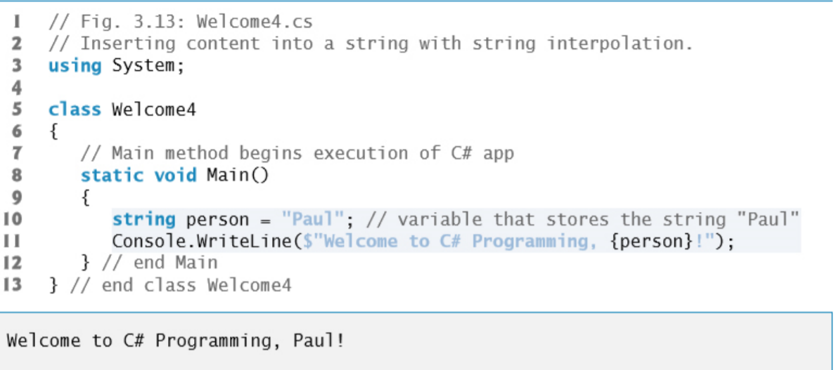

The **arithmetic operators** are summarized in following figure. (+,-,*,/)

**Chapter 4:**

Each **class** created by a developer becomes a new **type**, and it can be used by **any developer** to create objects, so C# is an extensible programming language.

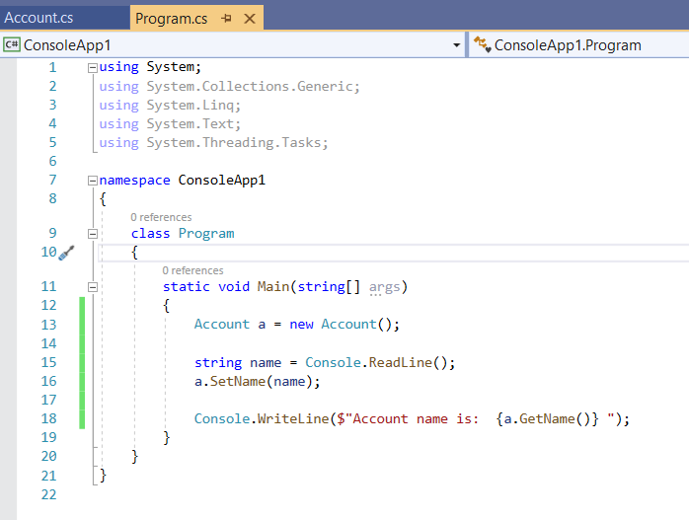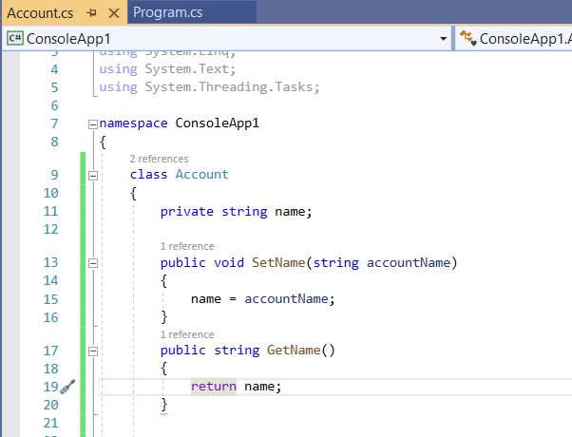

**class**, **property** and **method** names begin with an initial uppercase letter (**Pascal case**)

**variable** names begin with an initial lowercase letter (**camel** case).

**C# calling instance variable**: private string name; // instance variable

Access Modifier

The keyword **private** is an **access modifier**.

Instance variable name is private to indicate that name is accessible only to class Account’s methods

* and other members, like properties, as you’ll see in subsequent examples

**USING PROPERTY FOR GET AND SET**

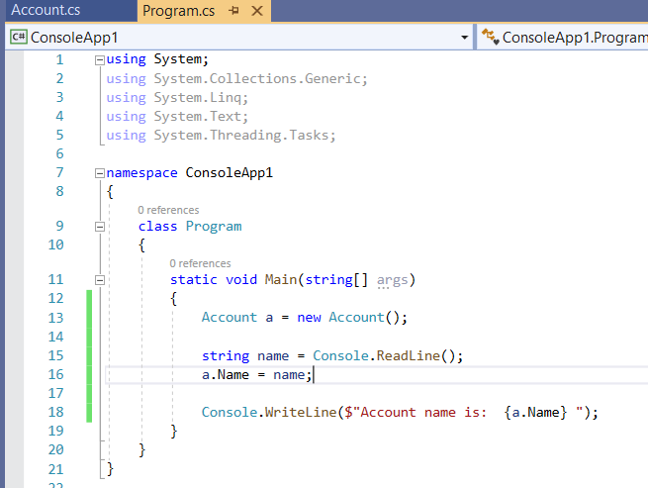

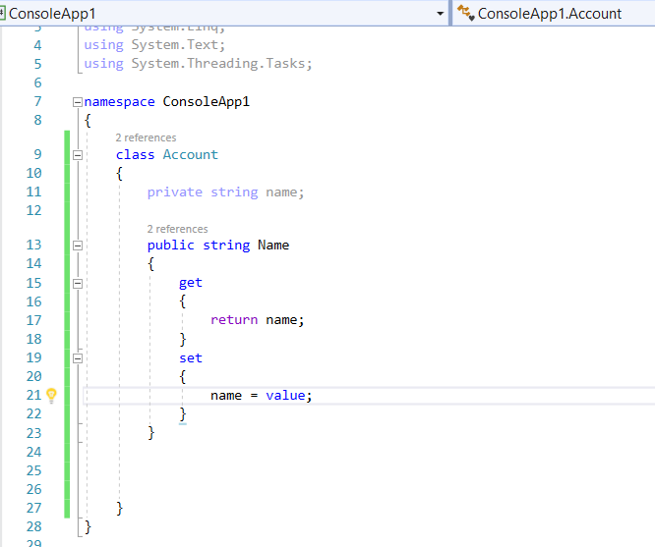

Output is whatever you type as name

**ADDING CONSTRUCTOR**

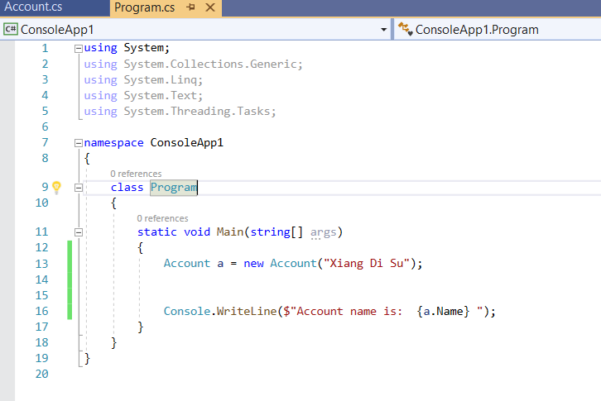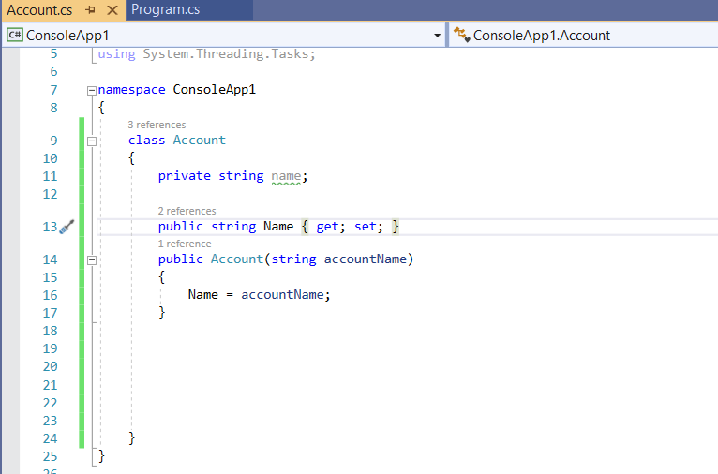

OUTPUT: Xiang di su

**ACCOUNT CLASS WITH A DECIMAL BALANCE INSTANCE VARIABLE**

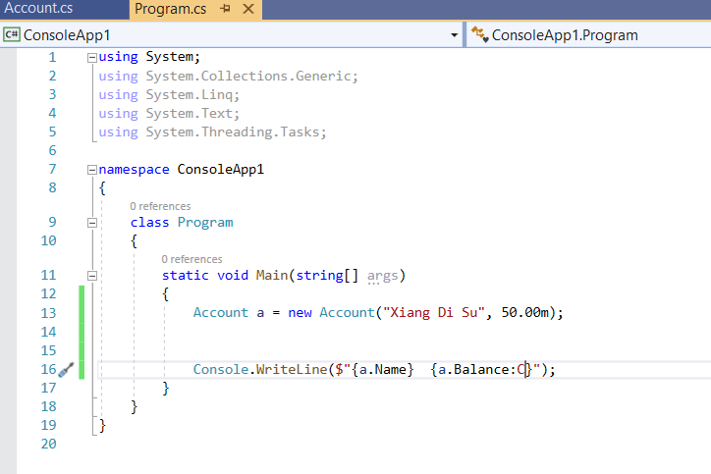

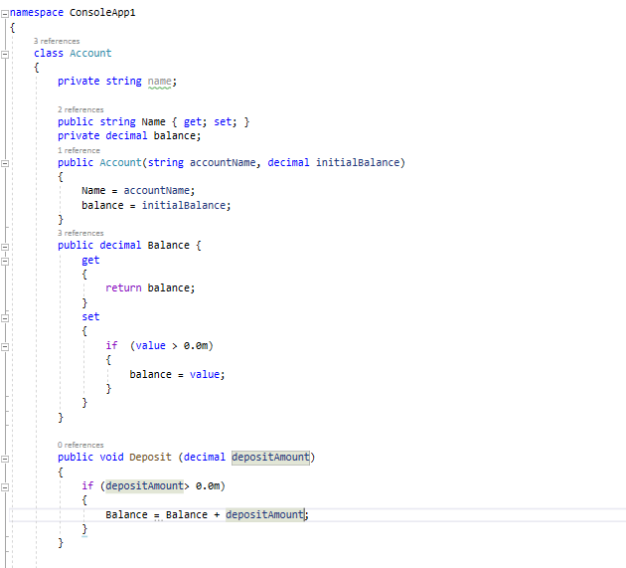

OUTPUT IS : “Xiang Di Su $50.00”

a.Balance:C means in dollar sign

**Creating deposit method to add the amount in balance**

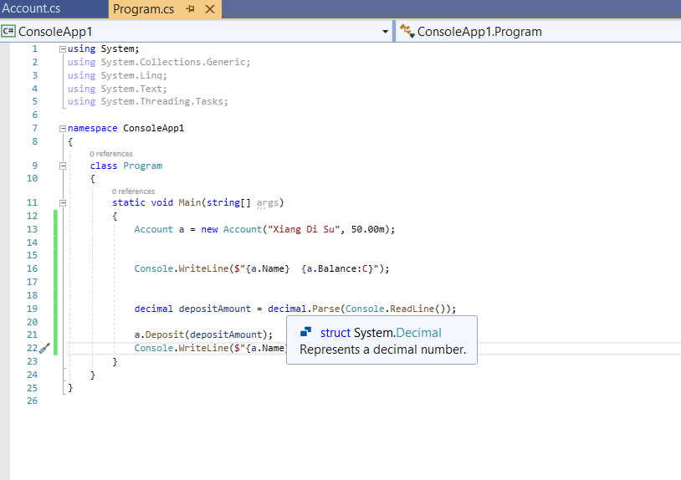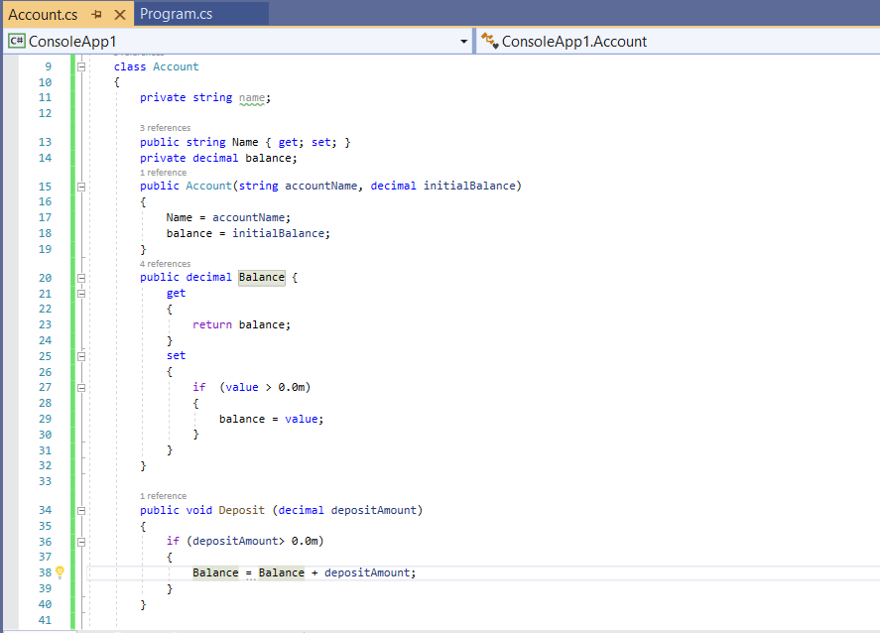

**Chapter 5 :**

The **pseudocode** statements are simply English statements that convey what task is to be performed in C#.

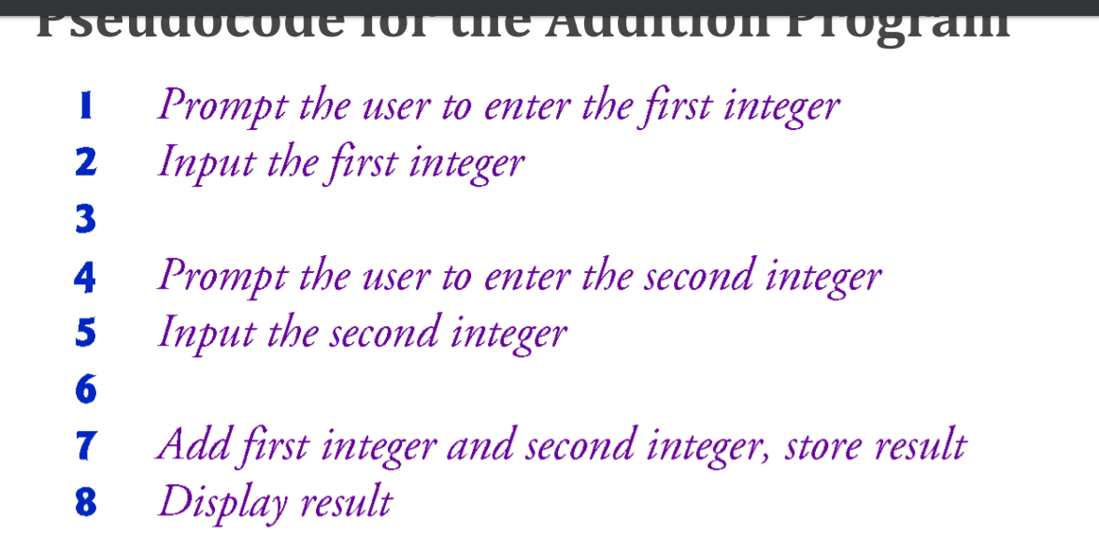

**If (single selection statement)**

**If else (double selection statement)**

**Nested if else (if else (if else if else if else)) or (if, else if , else if , else if , else)**

**Block:** Statements contained within a pair of braces ({ and }) form a **block**

Ex:

if (studentGrade >= 60)

{

Console.WriteLine("Passed");

}

else

{

Console.WriteLine("Failed");

Console.WriteLine("You must take this course again.");

}

The **conditional operator** (?:) can be used in place of an if…else statement.

Ex : Console.WriteLine(studentGrade >= 60 ? "Passed" : "Failed");

**STUDENT CLASS THAT STORES A STUDENT NAME, AVERAGE GRADE AND GRADE**

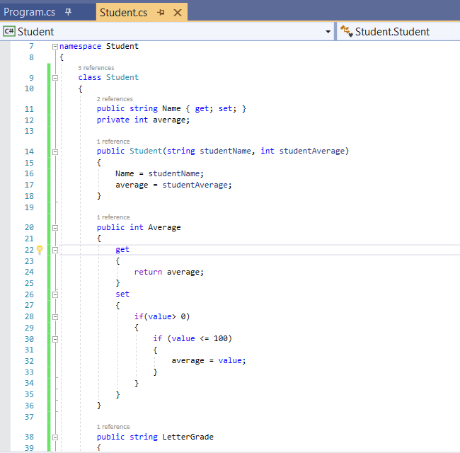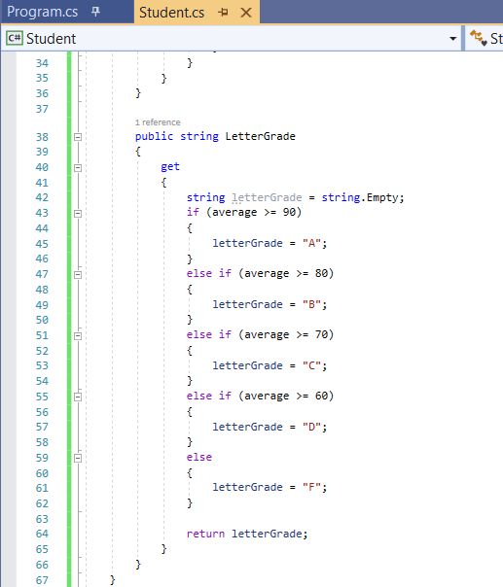

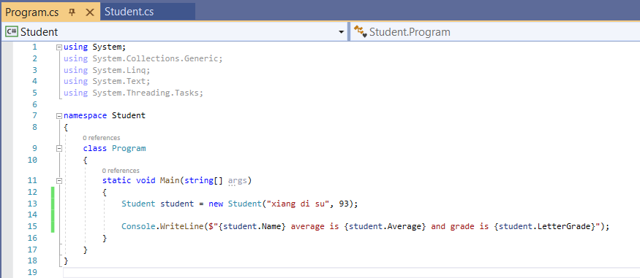

OUTPUT IS: Xiang di su average is 93 and grade is A

**While Iteration Statement**

**A iteration** statement allows you to specify that an app should repeat an action: consider a code segment designed to find the first power of 3 larger than 100:

Example:

Int product = 3;

While (product <= 100)

{

product = 3 * product

}

**First Refinement: initialize variable, input the 10 results (fixed)**

**COUNTER CONTROL ITERATION (WHILE LOOP) FOR CLASS AVERAGE**

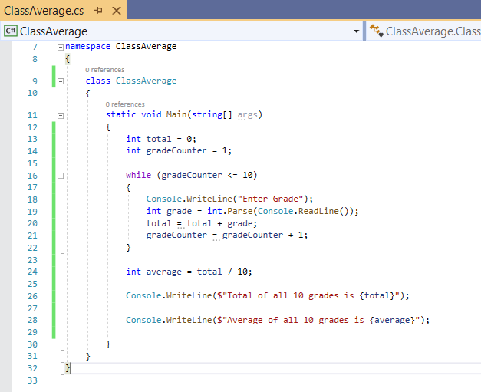

OUTPUT IS : enter grade times 10 and then gives total and average

**Second Refinement:** initialize total to 0 and counter = 0

**SENTINAL CONTROL ITERATION (WHILE LOOP)**

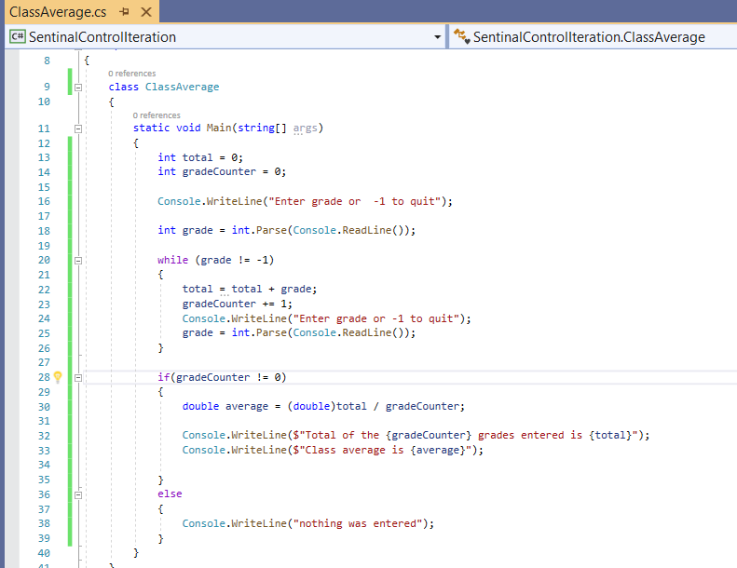

OUTPUT IS : 10 , 20 ,30 , -1 , total of the 3 grades entered is 60, class average is 20

{average:F} == xx.00

{price:C} == $xx.xx

**NESTED CONTROL STATEMENT (COMBINATION OF FIRST REFINEMENT AND SECOND REFINEMENT)**

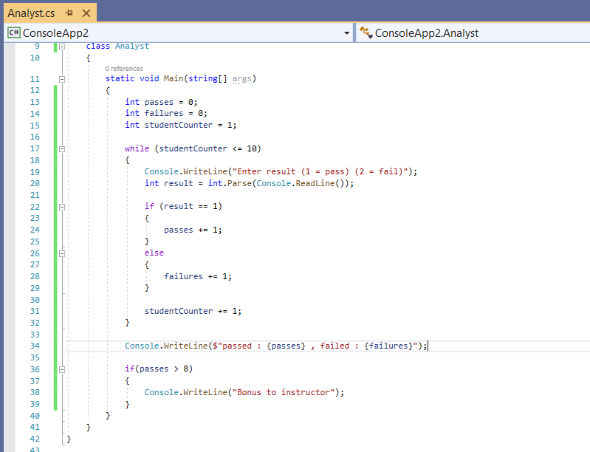

OUTPUT : 1 ,1,1,1,1,1,1,1,1,1 passed: 10 failed : 0 Bonus to instructor!

**Compound Assignment Operator:** C = C + 3; SAME AS C += 3;

**PREFIX INCREMENT AND POSTFIX OPERATOR**

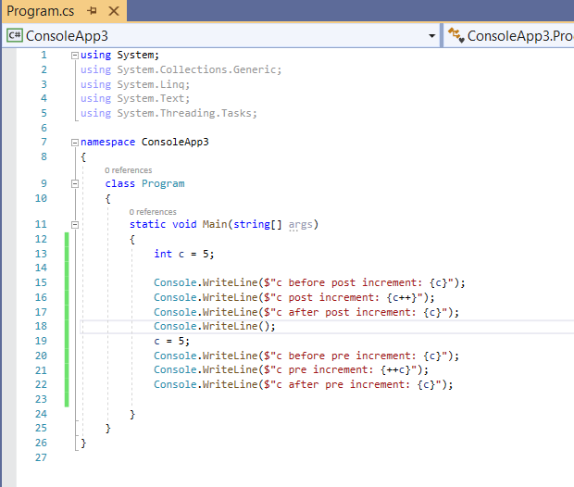

OUTPUT IS : post increment : 5, 5, 6 pre increment: 5, 6, 6

**Chapter 6**

**FOR LOOP ITERATION STATEMENT**

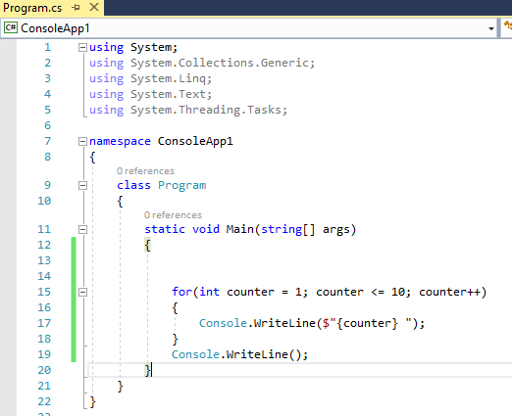

**SUMMING INTEGER WITH THE FOR STATEMENT**

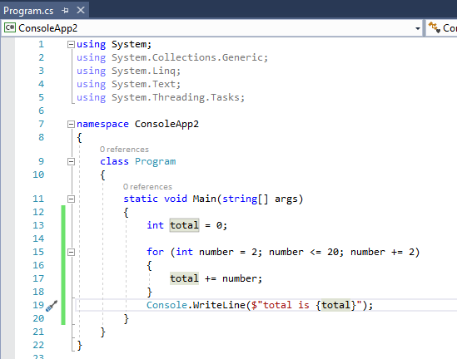

($"{year,4}{amount,20:C}") == 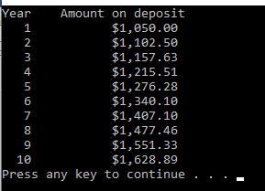

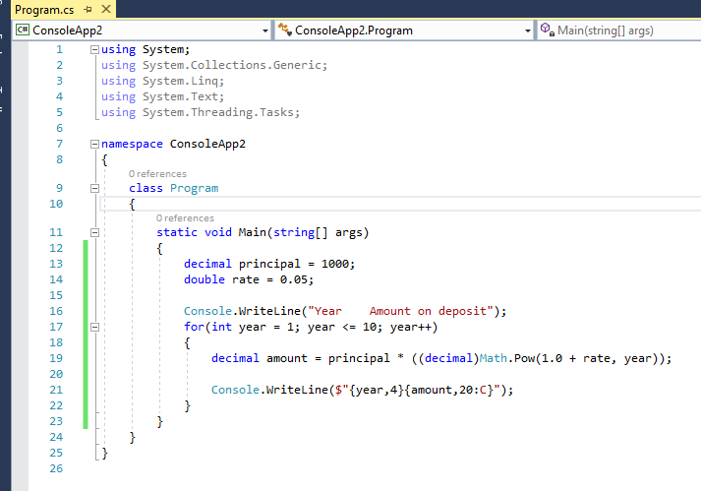

4 SPACE FOR THE YEAR AND 20 SPACES FOR THE AMOUNT WITH THE $ SIGN WHICH IS C

**DO WHILE ITERATION STATEMENT**

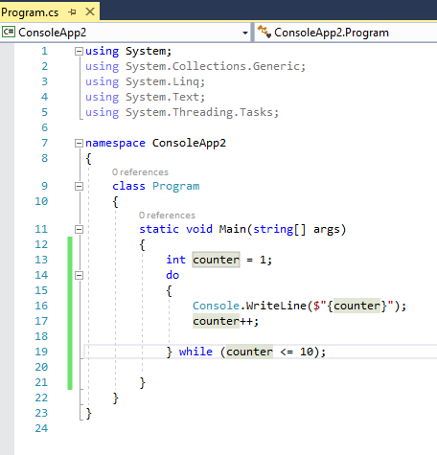

**USING A SWITCH STATEMENT TO COUNT LETTER GRADES (INTEGER)**

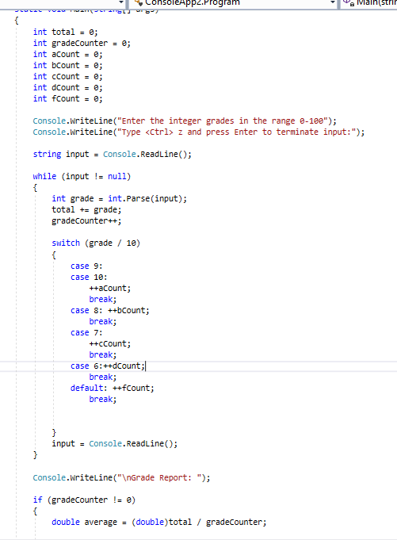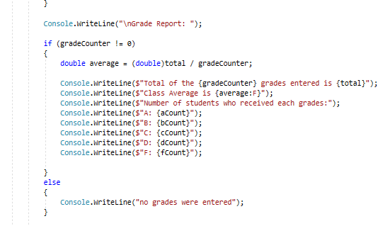

OUTPUT IS : if I enter 85 , grade = 85

85/10 = 8.5 it will do case 8 in the switch case, it will add a count in the bCount

**USING SWITCH CASE FOR STRINGS**

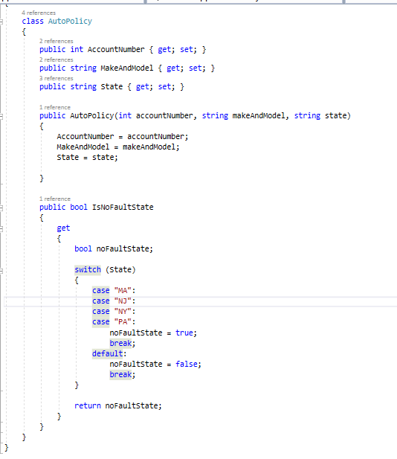

**Break Statement:** The **break** statement, when executed in a while, for, do…while , switch, or foreach, causes immediate exit from a loop or switch statement

**Continue statement:** The **continue** statement skips the remaining statements in the loop body and tests whether to proceed with the next iteration of the loop. (skips the loop of 5 if count == 5 {continue;})

**Logical Operator:** 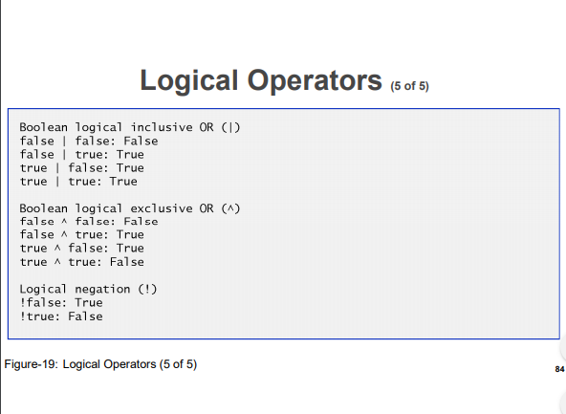

**Logical negation:** if (! **🡨 is called a logical negation)**

**Chapter 7**

**Calling Methods:** A method is invoked by a method call, and when the called method completes its task, it returns control and possibly a result to its caller.

**Static methods, static variables:**

A method that applies to the class in which it’s declared as a whole is known as a **static method**

To declare a method as **static**, place the keyword **static** before the **return type** in the method’s declaration

**Class Math:** Class Math provides a collection of static methods that enable a developer to perform common mathematical calculations.

**Why is Main declared Static? :** Declaring Main as static allows the execution environment to invoke Main without creating an instance of the class.

**METHOD MAXIMUM WITH 3 PARAMETERS**

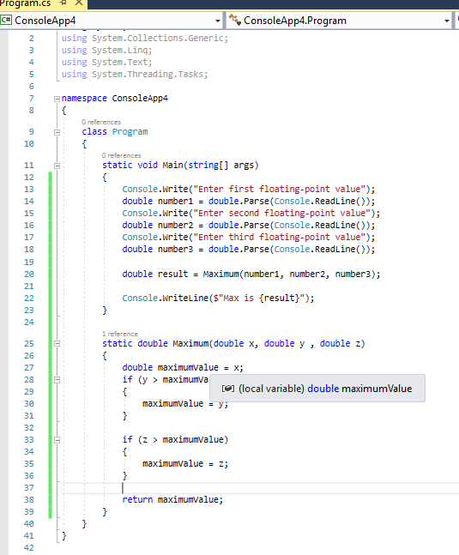

OUTPUT IS 10,20,30 -- maximum is 30

**ROLLING A SIX-SIDED DIE(RANDOM METHOD)**

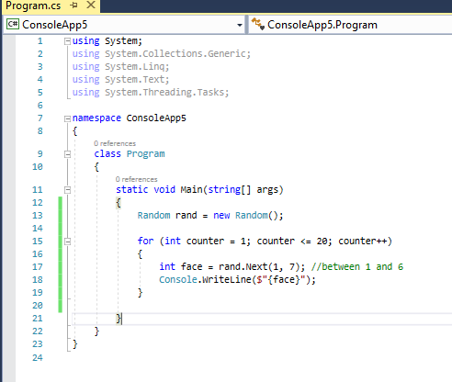

OUTPUT IS BETWEEN 1 AND 6 AND PRINTS 20 TIMES

**CHAPTER 8**

**Arrays**

**CHAPTER 9**

**INTRODUCTION TO LINQ and LIST COLLECTION**

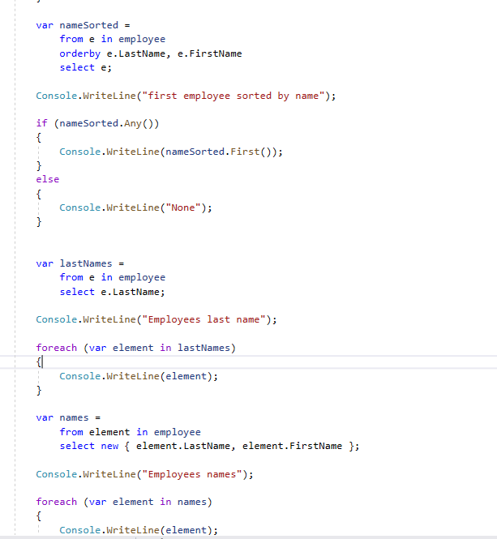

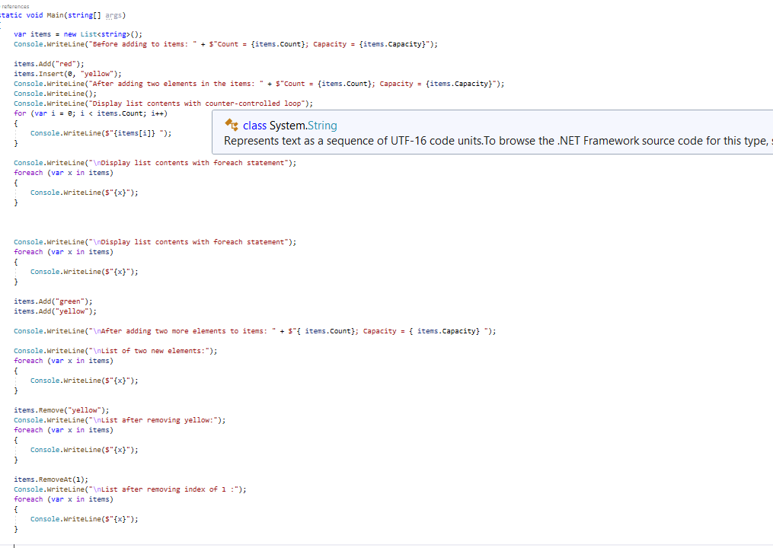

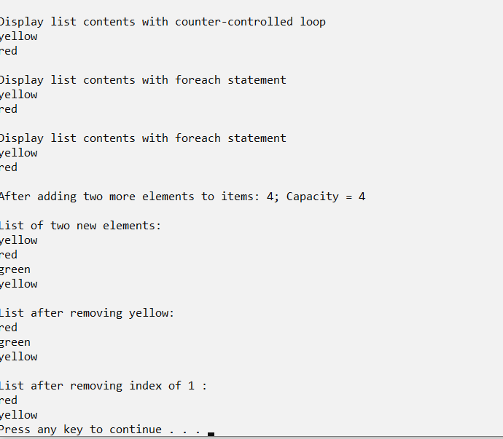

**USING LIST <string>**

